|  |  |
| --- | --- |
| [**Elementary school**](http://en.wikipedia.org/wiki/Elementary_school) | |
| [Preschool](http://en.wikipedia.org/wiki/Preschool) | 4–5 |
| [Kindergarten](http://en.wikipedia.org/wiki/Kindergarten) | 5–6 |
| [1st Grade](http://en.wikipedia.org/wiki/First_grade) | 6–7 |
| [2nd Grade](http://en.wikipedia.org/wiki/Second_grade) | 7–8 |
| [3rd Grade](http://en.wikipedia.org/wiki/Third_grade) | 8–9 |
| [4th Grade](http://en.wikipedia.org/wiki/Fourth_grade) | 9–10 |
| [5th Grade](http://en.wikipedia.org/wiki/Fifth_grade) | 10–11 |
| [**Middle school**](http://en.wikipedia.org/wiki/Secondary_education_in_the_United_States) | |
| [6th Grade](http://en.wikipedia.org/wiki/Sixth_grade) | 11–12 |
| [7th Grade](http://en.wikipedia.org/wiki/Seventh_grade) | 12–13 |
| [8th Grade](http://en.wikipedia.org/wiki/Eighth_grade) | 13–14 |
| [**High school**](http://en.wikipedia.org/wiki/Secondary_education_in_the_United_States) | |
| [9th Grade](http://en.wikipedia.org/wiki/Ninth_grade) (Freshman) | 14–15 |
| [10th Grade](http://en.wikipedia.org/wiki/Tenth_grade) (Sophomore) | 15–16 |
| [11th Grade](http://en.wikipedia.org/wiki/Eleventh_grade) (Junior) | 16–17 |
| [12th Grade](http://en.wikipedia.org/wiki/Twelfth_grade) (Senior) | 17–18 |
| [**Post-secondary education**](http://en.wikipedia.org/wiki/Post-secondary_education) | |
| [Tertiary education](http://en.wikipedia.org/wiki/Tertiary_education) ([College](http://en.wikipedia.org/wiki/College) or [University](http://en.wikipedia.org/wiki/University)) | Ages vary, but often 18–22 (Freshman, Sophomore, Junior and Senior years) |
| [Vocational education](http://en.wikipedia.org/wiki/Vocational_education) | Ages vary |
| [Graduate education](http://en.wikipedia.org/wiki/Graduate_education) | Ages vary |
| [Adult education](http://en.wikipedia.org/wiki/Adult_education) | Ages vary |

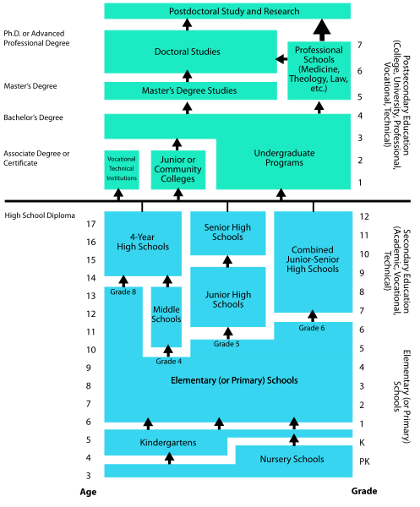

**BA, JD, PhD (UCLA), California Bar Exam Licence**

**BA (Yale), JD (Duke), PhD (Arizona)**



**Legal Practice in US**

In United States, The legal Practice can be divided in two times: Legal Education to become a lawyer and a Bar Admission to practice the profession.

# 1. Legal Education in the United States

The teenager goes first to a Junior High school (college) then a Senior High School (lycée).

1.1. College

In order to be accepted in a Law School, students must follow a basic four-year college or university degree. At the end of the College, the students obtain a BA, Bachelor of Arts, or a BS, Bachelor of sciences. The future lawyer generally chooses to get a BA degree.

During the four years of High School then of College, the student is successively named: Freshman (1st year), Sophomore (2nd year), Junior (3rd year) and Senior (4th year).

1.2. LSAT

After that, admission to practice as a lawyer requires completion of a degree program at one of the 175 law schools accredited by the American Bar Association. In order to choose a Law School, the student must take the LSAT: Law School Admission Test. According to the number of points obtained with that test, they then are able to choose their Law School. At the end, they are JD, Juris Doctor.

1.3. Law schools

It normally takes three years of full-time work to receive a law degree.

In the first year, students generally are required to take broad introductory topics such as torts, contracts, criminal law and procedure, civil procedure, (real or personal) property and constitutional law.

The second and third years of law school allow students to concentrate on particular areas of the law such as business law, litigation, international or family law. In addition, those years often provide the student with the chance to get some legal experience through legal aid clinics and internships.

In addition to the studies, the best Law students usually write, in part, in law reviews or take part in Moot Court by recreating a trial before a panel of judges.

In the end of Legal Education, in order to legal practice, the students must be allowed to Bar. They have to sit for an exam: there is one exam for every state.

# 2. Bar Admissions

The general requirements for admission to the bar are similar throughout the fifty states. An applicant must have good moral character, be a resident or employed in the state, graduated from an accredited law school and pass a Bar examination and knowledge of professional ethics.

State Bar examinations generally consist of two parts. The first part is a Multi-state Bar Examination, which tests one’s knowledge in basic areas of the law. The second part is specifically focused on the law of the specific state.

Upon admission to the bar an attorney normally must take an oath before the State Supreme Court declaring his or her obligations to the court, state, and country as an officer of the court, register with the court and receive a license to practice. A member of a bar of one state may be permitted to practice in another without further certification.

RANKING THE COLLEGES

### WSJ/THE **College Rankings 2021: top 10**

|  |  |  |  |  |
| --- | --- | --- | --- | --- |
| **Rank 2021** | **Rank 2020** | **Institution** | **City** | **State** |
| 1 | 1 | [Harvard University](https://www.timeshighereducation.com/world-university-rankings/harvard-university) | Cambridge | MA |
| 2 | 2 | [Massachusetts Institute of Technology](https://www.timeshighereducation.com/world-university-rankings/massachusetts-institute-technology) | Cambridge | MA |
| 3 | 3 | [Yale University](https://www.timeshighereducation.com/world-university-rankings/yale-university) | New Haven | CT |
| 4 | =7 | [Stanford University](https://www.timeshighereducation.com/world-university-rankings/stanford-university) | Stanford | CA |
| =5 | =7 | [Brown University](https://www.timeshighereducation.com/world-university-rankings/brown-university) | Providence | RI |
| =5 | 10 | [Duke University](https://www.timeshighereducation.com/world-university-rankings/duke-university) | Durham | NC |
| =7 | =5 | [California Institute of Technology](https://www.timeshighereducation.com/world-university-rankings/california-institute-technology) | Pasadena | CA |
| =7 | =5 | [Princeton University](https://www.timeshighereducation.com/world-university-rankings/princeton-university) | Princeton | NJ |
| 9 | 9 | [Cornell University](https://www.timeshighereducation.com/world-university-rankings/cornell-university) | Ithaca | NY |
| 10 | 11 | [Northwestern University](https://www.timeshighereducation.com/world-university-rankings/northwestern-university) | Evanston | IL |
|  |  |  |  |  |

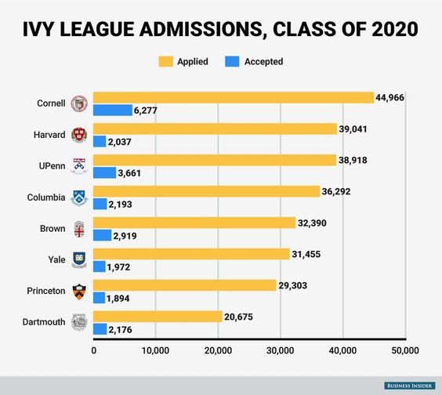

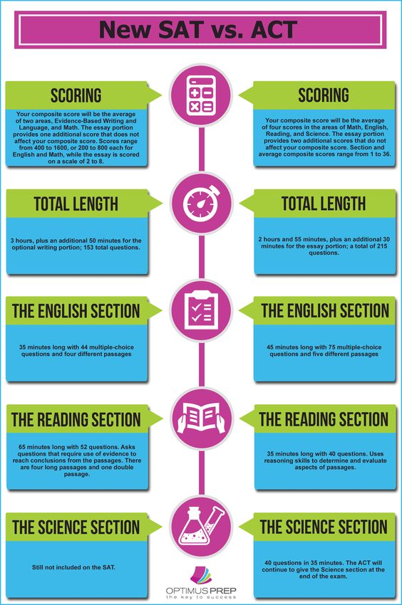

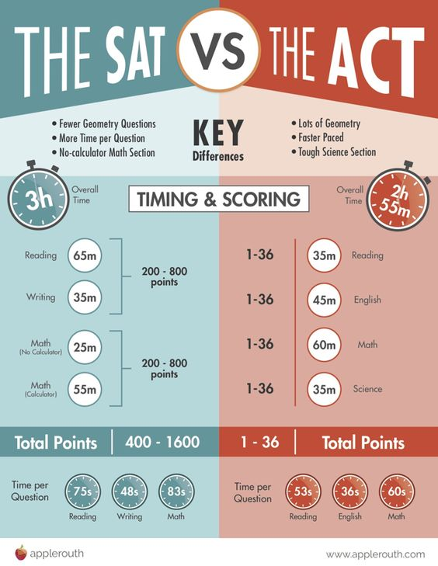

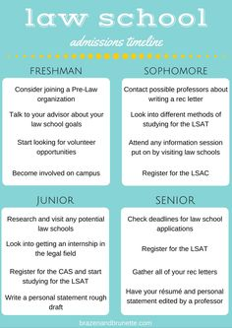

RANKING THE LAW SCHOOLS

US NEWS REPORT LAW SCHOOL RANKINGS 2020

|  |  |  |  |  |  |
| --- | --- | --- | --- | --- | --- |
| School Name | [Us News Ranking](http://schools.lawschoolnumbers.com/rankings/us-news-report-law-school-rankings?_=1603088292488&order=desc&sort=usnews_rank) | Acceptance Rate | Med.LSAT | Med.GPA | LSN Applications |
| [**Yale University**](http://yale.lawschoolnumbers.com/) | 1 | 10% | 173 | 3.93 | 6838 |
| [**Harvard University**](http://harvard.lawschoolnumbers.com/) | 2 | 18% | 173 | 3.86 | 13898 |
| [**Stanford University**](http://stanford.lawschoolnumbers.com/) | 2 | 12% | 171 | 3.89 | 9475 |
| [**University of Chicago**](http://chicago.lawschoolnumbers.com/) | 4 | 22% | 170 | 3.9 | 11802 |
| [**Columbia University**](http://columbia.lawschoolnumbers.com/) | 4 | 22% | 171 | 3.7 | 16041 |
| [**New York University**](http://nyu.lawschoolnumbers.com/) | 6 | 34% | 169 | 3.78 | 15433 |
| [**University of Pennsylvania**](http://penn.lawschoolnumbers.com/) | 7 | 19% | 169 | 3.89 | 13734 |
| [**University of Michigan Ann Arbor**](http://michigan.lawschoolnumbers.com/) | 8 | 28% | 168 | 3.76 | 14227 |
| [**University of Virginia**](http://uva.lawschoolnumbers.com/) | 8 | 21% | 168 | 3.86 | 15067 |
| [**University of California Berkeley**](http://berkeley.lawschoolnumbers.com/) | 8 | 22% | 166 | 3.78 | 13367 |
| [**Duke University**](http://duke.lawschoolnumbers.com/) | 11 | 24% | 169 | 3.76 | 14329 |
| [**Northwestern University**](http://northwestern.lawschoolnumbers.com/) | 12 | 23% | 168 | 3.77 | 10880 |
| [**Cornell University**](http://cornell.lawschoolnumbers.com/) | 13 | 31% | 167 | 3.74 | 11618 |
| [**Georgetown University**](http://gulc.lawschoolnumbers.com/) | 14 | 25% | 167 | 3.76 | 19915 |
| [**University of Texas Austin**](http://texas.lawschoolnumbers.com/) | 15 | 22% | 167 | 3.73 | 9385 |
| [**Vanderbilt University**](http://vanderbilt.lawschoolnumbers.com/) | 16 | 39% | 166 | 3.74 | 10015 |
| [**University of California Los Angeles**](http://ucla.lawschoolnumbers.com/) | 17 | 30% | 166 | 3.74 | 12561 |
| [**Washington University in St Louis**](http://washu.lawschoolnumbers.com/) | 18 | 28% | 167 | 3.67 | 8716 |
| [**University of Southern California**](http://usc.lawschoolnumbers.com/) | 19 | 30% | 166 | 3.76 | 9564 |
| [**Boston University**](http://bu.lawschoolnumbers.com/) | 20 | 38% | 163 | 3.67 | 10664 |

|  |  |  |  |  |  |
| --- | --- | --- | --- | --- | --- |
| [**University of Iowa**](http://iowa.lawschoolnumbers.com/) | 20 | 44% | 161 | 3.61 | 2682 |
| [**University of Notre Dame**](http://notredame.lawschoolnumbers.com/) | 22 | 36% | 164 | 3.66 | 5961 |
| [**Emory University**](http://emory.lawschoolnumbers.com/) | 22 | 33% | 165 | 3.77 | 7878 |
| [**University of Minnesota Twin Cities**](http://minnesota.lawschoolnumbers.com/) | 22 | 45% | 164 | 3.79 | 5143 |
| [**Indiana University Bloomington**](http://indiana.lawschoolnumbers.com/) | 25 | 54% | 161 | 3.76 | 4308 |
| [**Arizona State University**](http://asu.lawschoolnumbers.com/) | 25 | 44% | 161 | 3.63 | 3637 |
| [**George Washington University**](http://gw.lawschoolnumbers.com/) | 25 | 40% | 165 | 3.71 | 13841 |
| [**University of Alabama**](http://alabama.lawschoolnumbers.com/) | 28 | 37% | 163 | 3.76 | 2714 |
| [**University of California Irvine**](http://irvine.lawschoolnumbers.com/) | 28 | 27% | 162 | 3.56 | 2134 |
| [**Ohio State University**](http://osu.lawschoolnumbers.com/) | 30 | 50% | 159 | 3.61 | 3114 |
| [**Boston College**](http://bc.lawschoolnumbers.com/) | 30 | 46% | 162 | 3.56 | 9601 |
| [**University of California Davis**](http://davis.lawschoolnumbers.com/) | 30 | 32% | 163 | 3.51 | 4844 |
| [**University of Wisconsin Madison**](http://wisconsin.lawschoolnumbers.com/) | 33 | 49% | 161 | 3.54 | 3472 |
| [**University of Washington**](http://washington.lawschoolnumbers.com/) | 33 | 27% | 164 | 3.65 | 3903 |
| [**College of William and Mary**](http://wm.lawschoolnumbers.com/) | 33 | 37% | 163 | 3.69 | 8181 |
| [**University of Georgia**](http://georgia.lawschoolnumbers.com/) | 33 | 33% | 162 | 3.71 | 4083 |
| [**Fordham University**](http://fordham.lawschoolnumbers.com/) | 37 | 36% | 163 | 3.53 | 8905 |
| [**Whittier Law School**](http://whittier.lawschoolnumbers.com/) | 38 | 63% | 148 | 2.85 | 870 |
| [**University of North Carolina Chapel Hill**](http://unc.lawschoolnumbers.com/) | 38 | 45% | 161 | 3.49 | 3777 |
| [**Washington and Lee University**](http://wl.lawschoolnumbers.com/) | 40 | 49% | 160 | 3.41 | 6201 |

**2023**

[**Yale University**](https://www.usnews.com/best-graduate-schools/top-law-schools/yale-university-03027)

New Haven, CT

**[#1](https://www.usnews.com/best-graduate-schools/top-law-schools/law-rankings)**

[in](https://www.usnews.com/best-graduate-schools/top-law-schools/law-rankings)**[Best Law Schools](https://www.usnews.com/best-graduate-schools/top-law-schools/law-rankings)**

**TUITION AND FEES**

**$69,433**(full-time)

**ENROLLMENT (FULL-TIME)**

**636**

• [[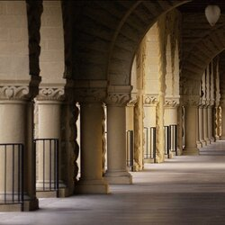](https://www.usnews.com/best-graduate-schools/top-law-schools/stanford-university-03014#photo-strip)](https://www.usnews.com/best-graduate-schools/top-law-schools/stanford-university-03014" \l "photo-strip)

**[View all 23 photos](https://www.usnews.com/best-graduate-schools/top-law-schools/stanford-university-03014" \l "photo-strip)**

[**Stanford University**](https://www.usnews.com/best-graduate-schools/top-law-schools/stanford-university-03014)

Stanford, CA

**[#2](https://www.usnews.com/best-graduate-schools/top-law-schools/law-rankings)**

[in](https://www.usnews.com/best-graduate-schools/top-law-schools/law-rankings)**[Best Law Schools](https://www.usnews.com/best-graduate-schools/top-law-schools/law-rankings)**

**TUITION AND FEES**

**$66,396**(full-time)

**ENROLLMENT (FULL-TIME)**

**577**

• [[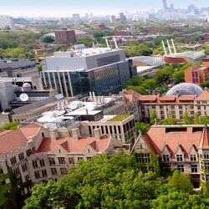](https://www.usnews.com/best-graduate-schools/top-law-schools/university-of-chicago-03052#photo-strip)](https://www.usnews.com/best-graduate-schools/top-law-schools/university-of-chicago-03052" \l "photo-strip)

**[View all 18 photos](https://www.usnews.com/best-graduate-schools/top-law-schools/university-of-chicago-03052" \l "photo-strip)**

[**University of Chicago**](https://www.usnews.com/best-graduate-schools/top-law-schools/university-of-chicago-03052)

Chicago, IL

**[#3](https://www.usnews.com/best-graduate-schools/top-law-schools/law-rankings)**

[in](https://www.usnews.com/best-graduate-schools/top-law-schools/law-rankings)**[Best Law Schools](https://www.usnews.com/best-graduate-schools/top-law-schools/law-rankings)**

**TUITION AND FEES**

**$72,081**(full-time)

**ENROLLMENT (FULL-TIME)**

**626**

](https://www.usnews.com/best-graduate-schools/top-law-schools/columbia-university-03104#photo-strip)](https://www.usnews.com/best-graduate-schools/top-law-schools/columbia-university-03104" \l "photo-strip)

**[View all 17 photos](https://www.usnews.com/best-graduate-schools/top-law-schools/columbia-university-03104" \l "photo-strip)**

[**Columbia University**](https://www.usnews.com/best-graduate-schools/top-law-schools/columbia-university-03104)

New York, NY

**[#4](https://www.usnews.com/best-graduate-schools/top-law-schools/law-rankings)**

[in](https://www.usnews.com/best-graduate-schools/top-law-schools/law-rankings)**[Best Law Schools](https://www.usnews.com/best-graduate-schools/top-law-schools/law-rankings)**[(tie)](https://www.usnews.com/best-graduate-schools/top-law-schools/law-rankings)

**TUITION AND FEES**

**$76,088**(full-time)

**ENROLLMENT (FULL-TIME)**

**1,293**

• [[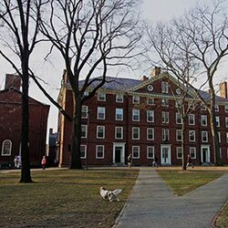](https://www.usnews.com/best-graduate-schools/top-law-schools/harvard-university-03074#photo-strip)](https://www.usnews.com/best-graduate-schools/top-law-schools/harvard-university-03074" \l "photo-strip)

**[View all 6 photos](https://www.usnews.com/best-graduate-schools/top-law-schools/harvard-university-03074" \l "photo-strip)**

[**Harvard University**](https://www.usnews.com/best-graduate-schools/top-law-schools/harvard-university-03074)

Cambridge, MA

**[#4](https://www.usnews.com/best-graduate-schools/top-law-schools/law-rankings)**

[in](https://www.usnews.com/best-graduate-schools/top-law-schools/law-rankings)**[Best Law Schools](https://www.usnews.com/best-graduate-schools/top-law-schools/law-rankings)**[(tie)](https://www.usnews.com/best-graduate-schools/top-law-schools/law-rankings)

**TUITION AND FEES**

**$68,962**(full-time)

**ENROLLMENT (FULL-TIME)**

**1,747**

• [[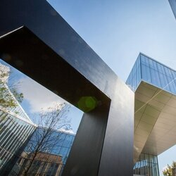](https://www.usnews.com/best-graduate-schools/top-law-schools/university-of-pennsylvania-03140#photo-strip)](https://www.usnews.com/best-graduate-schools/top-law-schools/university-of-pennsylvania-03140" \l "photo-strip)

**[View all 9 photos](https://www.usnews.com/best-graduate-schools/top-law-schools/university-of-pennsylvania-03140" \l "photo-strip)**

[**University of Pennsylvania (Carey)**](https://www.usnews.com/best-graduate-schools/top-law-schools/university-of-pennsylvania-03140)

Philadelphia, PA

**[#6](https://www.usnews.com/best-graduate-schools/top-law-schools/law-rankings)**

[in](https://www.usnews.com/best-graduate-schools/top-law-schools/law-rankings)**[Best Law Schools](https://www.usnews.com/best-graduate-schools/top-law-schools/law-rankings)**

**TUITION AND FEES**

**$70,042**(full-time)

**ENROLLMENT (FULL-TIME)**

**824**

](https://www.usnews.com/best-graduate-schools/top-law-schools/new-york-university-03110#photo-strip)](https://www.usnews.com/best-graduate-schools/top-law-schools/new-york-university-03110" \l "photo-strip)

**[View all 9 photos](https://www.usnews.com/best-graduate-schools/top-law-schools/new-york-university-03110" \l "photo-strip)**

[**New York University**](https://www.usnews.com/best-graduate-schools/top-law-schools/new-york-university-03110)

New York, NY

**[#7](https://www.usnews.com/best-graduate-schools/top-law-schools/law-rankings)**

[in](https://www.usnews.com/best-graduate-schools/top-law-schools/law-rankings)**[Best Law Schools](https://www.usnews.com/best-graduate-schools/top-law-schools/law-rankings)**

**TUITION AND FEES**

**$73,414**(full-time)

**ENROLLMENT (FULL-TIME)**

**1,413**

**MEDIAN LSAT (FULL-TIME)**

• [[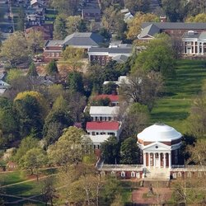](https://www.usnews.com/best-graduate-schools/top-law-schools/university-of-virginia-main-campus-03162#photo-strip)](https://www.usnews.com/best-graduate-schools/top-law-schools/university-of-virginia-main-campus-03162" \l "photo-strip)

**[View all 4 photos](https://www.usnews.com/best-graduate-schools/top-law-schools/university-of-virginia-main-campus-03162" \l "photo-strip)**

[**University of Virginia**](https://www.usnews.com/best-graduate-schools/top-law-schools/university-of-virginia-main-campus-03162)

Charlottesville, VA

**[#8](https://www.usnews.com/best-graduate-schools/top-law-schools/law-rankings)**

[in](https://www.usnews.com/best-graduate-schools/top-law-schools/law-rankings)**[Best Law Schools](https://www.usnews.com/best-graduate-schools/top-law-schools/law-rankings)**

**TUITION AND FEES**

**$66,500**(in-state, full-time)

**$69,500**(out-of-state, full-time)

**ENROLLMENT (FULL-TIME)**

**922**

• [[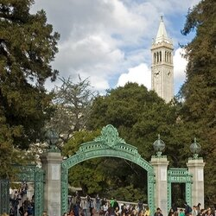](https://www.usnews.com/best-graduate-schools/top-law-schools/university-of-california-berkeley-03016#photo-strip)](https://www.usnews.com/best-graduate-schools/top-law-schools/university-of-california-berkeley-03016" \l "photo-strip)

**[View all 13 photos](https://www.usnews.com/best-graduate-schools/top-law-schools/university-of-california-berkeley-03016" \l "photo-strip)**

[**University of California--Berkeley**](https://www.usnews.com/best-graduate-schools/top-law-schools/university-of-california-berkeley-03016)

Berkeley, CA

**[#9](https://www.usnews.com/best-graduate-schools/top-law-schools/law-rankings)**

[in](https://www.usnews.com/best-graduate-schools/top-law-schools/law-rankings)**[Best Law Schools](https://www.usnews.com/best-graduate-schools/top-law-schools/law-rankings)**

**TUITION AND FEES**

**$56,858**(in-state, full-time)

**$62,143**(out-of-state, full-time)

**ENROLLMENT (FULL-TIME)**

**1,088**

**MEDIAN LSAT (FULL-TIME)**

](https://www.usnews.com/best-graduate-schools/top-law-schools/university-of-michigan-ann-arbor-03082#photo-strip)](https://www.usnews.com/best-graduate-schools/top-law-schools/university-of-michigan-ann-arbor-03082" \l "photo-strip)

**[View all 20 photos](https://www.usnews.com/best-graduate-schools/top-law-schools/university-of-michigan-ann-arbor-03082" \l "photo-strip)**

[**University of Michigan--Ann Arbor**](https://www.usnews.com/best-graduate-schools/top-law-schools/university-of-michigan-ann-arbor-03082)

Ann Arbor, MI

**[#10](https://www.usnews.com/best-graduate-schools/top-law-schools/law-rankings)**

[in](https://www.usnews.com/best-graduate-schools/top-law-schools/law-rankings)**[Best Law Schools](https://www.usnews.com/best-graduate-schools/top-law-schools/law-rankings)**

The Law School at University of Michigan--Ann Arbor has an application deadline of Feb. 28. The full-time program... [**READ MORE »**](https://www.usnews.com/best-graduate-schools/top-law-schools/university-of-michigan-ann-arbor-03082)

**TUITION AND FEES**

**$64,098**(in-state, full-time)

**$67,098**(out-of-state, full-time)

**ENROLLMENT (FULL-TIME)**

**964**

](https://www.usnews.com/best-graduate-schools/top-law-schools/duke-university-03117#photo-strip)](https://www.usnews.com/best-graduate-schools/top-law-schools/duke-university-03117" \l "photo-strip)

**[View all 16 photos](https://www.usnews.com/best-graduate-schools/top-law-schools/duke-university-03117" \l "photo-strip)**

[**Duke University**](https://www.usnews.com/best-graduate-schools/top-law-schools/duke-university-03117)

Durham, NC

**[#11](https://www.usnews.com/best-graduate-schools/top-law-schools/law-rankings)**

[in](https://www.usnews.com/best-graduate-schools/top-law-schools/law-rankings)**[Best Law Schools](https://www.usnews.com/best-graduate-schools/top-law-schools/law-rankings)**

**TUITION AND FEES**

**$68,400**(full-time)

**ENROLLMENT (FULL-TIME)**

**742**

](https://www.usnews.com/best-graduate-schools/top-law-schools/cornell-university-03105#photo-strip)](https://www.usnews.com/best-graduate-schools/top-law-schools/cornell-university-03105" \l "photo-strip)

**[View all 5 photos](https://www.usnews.com/best-graduate-schools/top-law-schools/cornell-university-03105" \l "photo-strip)**

[**Cornell University**](https://www.usnews.com/best-graduate-schools/top-law-schools/cornell-university-03105)

Ithaca, NY

**[#12](https://www.usnews.com/best-graduate-schools/top-law-schools/law-rankings)**

[in](https://www.usnews.com/best-graduate-schools/top-law-schools/law-rankings)**[Best Law Schools](https://www.usnews.com/best-graduate-schools/top-law-schools/law-rankings)**

**TUITION AND FEES**

**$71,608**(full-time)

**ENROLLMENT (FULL-TIME)**

**580**

](https://www.usnews.com/best-graduate-schools/top-law-schools/northwestern-university-03050#photo-strip)](https://www.usnews.com/best-graduate-schools/top-law-schools/northwestern-university-03050" \l "photo-strip)

**[View all 14 photos](https://www.usnews.com/best-graduate-schools/top-law-schools/northwestern-university-03050" \l "photo-strip)**

[**Northwestern University (Pritzker)**](https://www.usnews.com/best-graduate-schools/top-law-schools/northwestern-university-03050)

Chicago, IL

**[#13](https://www.usnews.com/best-graduate-schools/top-law-schools/law-rankings)**

[in](https://www.usnews.com/best-graduate-schools/top-law-schools/law-rankings)**[Best Law Schools](https://www.usnews.com/best-graduate-schools/top-law-schools/law-rankings)**

**TUITION AND FEES**

**$69,650**(full-time)

**ENROLLMENT (FULL-TIME)**

**769**

• [[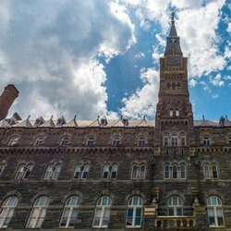](https://www.usnews.com/best-graduate-schools/top-law-schools/georgetown-university-03032#photo-strip)](https://www.usnews.com/best-graduate-schools/top-law-schools/georgetown-university-03032" \l "photo-strip)

**[View all 16 photos](https://www.usnews.com/best-graduate-schools/top-law-schools/georgetown-university-03032" \l "photo-strip)**

[**Georgetown University**](https://www.usnews.com/best-graduate-schools/top-law-schools/georgetown-university-03032)

Washington, DC

**[#14](https://www.usnews.com/best-graduate-schools/top-law-schools/law-rankings)**

[in](https://www.usnews.com/best-graduate-schools/top-law-schools/law-rankings)**[Best Law Schools](https://www.usnews.com/best-graduate-schools/top-law-schools/law-rankings)**

The Law Center at Georgetown University has an application deadline of March 1. The full-time program application fee... [**READ MORE »**](https://www.usnews.com/best-graduate-schools/top-law-schools/georgetown-university-03032)

**TUITION AND FEES**

**$69,280**(full-time)

**$47,006**(part-time)

**ENROLLMENT (FULL-TIME)**

**1,798**

• [[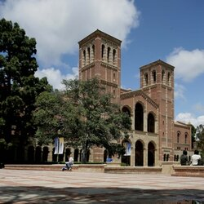](https://www.usnews.com/best-graduate-schools/top-law-schools/university-of-california-los-angeles-03018#photo-strip)](https://www.usnews.com/best-graduate-schools/top-law-schools/university-of-california-los-angeles-03018" \l "photo-strip)

**[View all 7 photos](https://www.usnews.com/best-graduate-schools/top-law-schools/university-of-california-los-angeles-03018" \l "photo-strip)**

[**University of California--Los Angeles**](https://www.usnews.com/best-graduate-schools/top-law-schools/university-of-california-los-angeles-03018)

Los Angeles, CA

**[#15](https://www.usnews.com/best-graduate-schools/top-law-schools/law-rankings)**

[in](https://www.usnews.com/best-graduate-schools/top-law-schools/law-rankings)**[Best Law Schools](https://www.usnews.com/best-graduate-schools/top-law-schools/law-rankings)**

The School of Law at University of California--Los Angeles has an application deadline of Feb. 1. The full-time program... [**READ MORE »**](https://www.usnews.com/best-graduate-schools/top-law-schools/university-of-california-los-angeles-03018)

**TUITION AND FEES**

**$52,468**(in-state, full-time)

**$60,739**(out-of-state, full-time)

**ENROLLMENT (FULL-TIME)**

**1,038**

](https://www.usnews.com/best-graduate-schools/top-law-schools/washington-university-in-st-louis-03092#photo-strip)](https://www.usnews.com/best-graduate-schools/top-law-schools/washington-university-in-st-louis-03092" \l "photo-strip)

**[View all 14 photos](https://www.usnews.com/best-graduate-schools/top-law-schools/washington-university-in-st-louis-03092" \l "photo-strip)**

[**Washington University in St. Louis**](https://www.usnews.com/best-graduate-schools/top-law-schools/washington-university-in-st-louis-03092)

St. Louis, MO

**[#16](https://www.usnews.com/best-graduate-schools/top-law-schools/law-rankings)**

[in](https://www.usnews.com/best-graduate-schools/top-law-schools/law-rankings)**[Best Law Schools](https://www.usnews.com/best-graduate-schools/top-law-schools/law-rankings)**

The School of Law at Washington University in St. Louis has an application deadline of Aug. 10. The full-time program... [**READ MORE »**](https://www.usnews.com/best-graduate-schools/top-law-schools/washington-university-in-st-louis-03092)

**TUITION AND FEES**

**$63,364**(full-time)

**ENROLLMENT (FULL-TIME)**

**744**

](https://www.usnews.com/best-graduate-schools/top-law-schools/boston-university-03073#photo-strip)](https://www.usnews.com/best-graduate-schools/top-law-schools/boston-university-03073" \l "photo-strip)

**[View all 25 photos](https://www.usnews.com/best-graduate-schools/top-law-schools/boston-university-03073" \l "photo-strip)**

[**Boston University**](https://www.usnews.com/best-graduate-schools/top-law-schools/boston-university-03073)

Boston, MA

**[#17](https://www.usnews.com/best-graduate-schools/top-law-schools/law-rankings)**

[in](https://www.usnews.com/best-graduate-schools/top-law-schools/law-rankings)**[Best Law Schools](https://www.usnews.com/best-graduate-schools/top-law-schools/law-rankings)**[(tie)](https://www.usnews.com/best-graduate-schools/top-law-schools/law-rankings)

**TUITION AND FEES**

**$60,718**(full-time)

**ENROLLMENT (FULL-TIME)**

**796**

**MEDIAN LSAT (FULL-TIME)**

](https://www.usnews.com/best-graduate-schools/top-law-schools/the-university-of-texas-at-austin-03155#photo-strip)](https://www.usnews.com/best-graduate-schools/top-law-schools/the-university-of-texas-at-austin-03155" \l "photo-strip)

**[View all 14 photos](https://www.usnews.com/best-graduate-schools/top-law-schools/the-university-of-texas-at-austin-03155" \l "photo-strip)**

[**University of Texas--Austin**](https://www.usnews.com/best-graduate-schools/top-law-schools/the-university-of-texas-at-austin-03155)

Austin, TX

**[#17](https://www.usnews.com/best-graduate-schools/top-law-schools/law-rankings)**

[in](https://www.usnews.com/best-graduate-schools/top-law-schools/law-rankings)**[Best Law Schools](https://www.usnews.com/best-graduate-schools/top-law-schools/law-rankings)**[(tie)](https://www.usnews.com/best-graduate-schools/top-law-schools/law-rankings)

The School of Law at University of Texas--Austin has an application deadline of March 1. The full-time program... [**READ MORE »**](https://www.usnews.com/best-graduate-schools/top-law-schools/the-university-of-texas-at-austin-03155)

**TUITION AND FEES**

**$36,429**(in-state, full-time)

**$54,096**(out-of-state, full-time)

**ENROLLMENT (FULL-TIME)**

**998**

• [[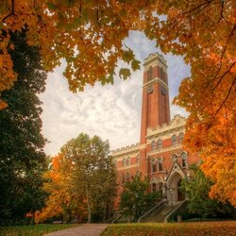](https://www.usnews.com/best-graduate-schools/top-law-schools/vanderbilt-university-03147#photo-strip)](https://www.usnews.com/best-graduate-schools/top-law-schools/vanderbilt-university-03147" \l "photo-strip)

**[View all 25 photos](https://www.usnews.com/best-graduate-schools/top-law-schools/vanderbilt-university-03147" \l "photo-strip)**

[**Vanderbilt University**](https://www.usnews.com/best-graduate-schools/top-law-schools/vanderbilt-university-03147)

Nashville, TN

**[#17](https://www.usnews.com/best-graduate-schools/top-law-schools/law-rankings)**

[in](https://www.usnews.com/best-graduate-schools/top-law-schools/law-rankings)**[Best Law Schools](https://www.usnews.com/best-graduate-schools/top-law-schools/law-rankings)**[(tie)](https://www.usnews.com/best-graduate-schools/top-law-schools/law-rankings)

The Law School at Vanderbilt University has an application deadline of April 1. The full-time program application fee... [**READ MORE »**](https://www.usnews.com/best-graduate-schools/top-law-schools/vanderbilt-university-03147)

**TUITION AND FEES**

**$64,284**(full-time)

**ENROLLMENT (FULL-TIME)**

**544**

• [[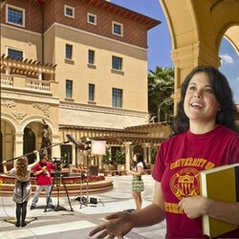](https://www.usnews.com/best-graduate-schools/top-law-schools/university-of-southern-california-03021#photo-strip)](https://www.usnews.com/best-graduate-schools/top-law-schools/university-of-southern-california-03021" \l "photo-strip)

**[View all 11 photos](https://www.usnews.com/best-graduate-schools/top-law-schools/university-of-southern-california-03021" \l "photo-strip)**

[**University of Southern California (Gould)**](https://www.usnews.com/best-graduate-schools/top-law-schools/university-of-southern-california-03021)

Los Angeles, CA

**[#20](https://www.usnews.com/best-graduate-schools/top-law-schools/law-rankings)**

[in](https://www.usnews.com/best-graduate-schools/top-law-schools/law-rankings)**[Best Law Schools](https://www.usnews.com/best-graduate-schools/top-law-schools/law-rankings)**

**TUITION AND FEES**

**$70,998**(full-time)

**ENROLLMENT (FULL-TIME)**

**613**

• [[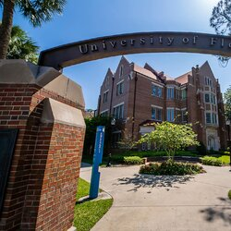](https://www.usnews.com/best-graduate-schools/top-law-schools/university-of-florida-03037#photo-strip)](https://www.usnews.com/best-graduate-schools/top-law-schools/university-of-florida-03037" \l "photo-strip)

**[View all 20 photos](https://www.usnews.com/best-graduate-schools/top-law-schools/university-of-florida-03037" \l "photo-strip)**

[**University of Florida (Levin)**](https://www.usnews.com/best-graduate-schools/top-law-schools/university-of-florida-03037)

Gainesville, FL

**[#21](https://www.usnews.com/best-graduate-schools/top-law-schools/law-rankings)**

[in](https://www.usnews.com/best-graduate-schools/top-law-schools/law-rankings)**[Best Law Schools](https://www.usnews.com/best-graduate-schools/top-law-schools/law-rankings)**[(tie)](https://www.usnews.com/best-graduate-schools/top-law-schools/law-rankings)

Five law schools repeated last year's results when they snagged the top spots in rankings released Tuesday by U.S. News & World Report.

No. 1 is Yale Law School, followed by Stanford Law School, Harvard Law School and, in a tie for fourth place, Columbia Law School and the University of Chicago Law School, according to U.S. News & World Report’s [2022 rankings](https://www.usnews.com/best-graduate-schools?src=usn_pr).

The same schools took the top spots in the [2021 rankings](https://www.abajournal.com/news/article/little-movement-in-new-us-news-world-report-law-school-rankings), but there were some small changes in the top 14 list.

The University of Pennsylvania Carey Law School moved up from the No. 7 spot to No. 6, tying with the New York University School of Law. The Duke University School of Law moved up from the No. 12 spot to No. 10, tying with the University of Michigan Law School at Ann Arbor, which was tied for No. 9 last year with two other schools. And the Northwestern University Pritzker School of Law, tied at No. 9 last year, has dropped to No. 12.

There is a new change in methodology. For the first time, the rankings take into account the average debt incurred in obtaining a law degree and the percentage of law school graduates incurring law school debt. But the weight given to both factors in the rankings is small, at 0.03 and 0.02, respectively.

The schools’ debt numbers were calculated by comparing the schools’ average debt value with the median debt value for all schools. Schools whose values were farthest below the median scored the highest on each indicator, and schools that were most above the median scored the lowest.

But U.S. News & World Report scrapped a plan to release a stand-alone law school diversity ranking after deans from 162 law schools asked for a revision, report [Law.com](https://www.law.com/newyorklawjournal/2021/03/25/us-news-makes-last-minute-changes-to-law-school-rankings-fueling-criticism-and-concern/) and [Reuters Legal](https://today.westlaw.com/Document/I2ea6be208dc711ebb3b7b5bc2f979fe9/View/FullText.html?transitionType=Default&contextData=(sc.Default)&firstPage=true).

The deans complained that students of more than one race were wrongly excluded from the calculation. U.S. News & World Report plans to publish the diversity ranking at a later, undetermined date, Bob Morse, chief data strategist for U.S. News & World Report, told Law.com in an email.

The top 14 law schools, along with the average indebtedness of their 2020 JD graduates who incurred law school debt, are:

1) Yale University, $135,680

2) Stanford University, $146,235

3) Harvard University, $170,866

4) Columbia University (tie), $190,141

4) University of Chicago (tie), $191,117

6) New York University (tie), $174,780

6) University of Pennsylvania (tie), $163,383

8) University of Virginia, $165,911

9) University of California at Berkeley, $139,251

10) Duke University (tie), $153,276

10) University of Michigan at Ann Arbor (tie), $129,791

12) Northwestern University, 154,844

13) Cornell University, $150,089

14) University of California at Los Angeles, $125,167

Some law schools had considerably lower average indebtedness, including these schools coming in below $70,000:

• University of Alabama, ranked No. 25, at $64,271

• Brigham Young University, ranked No. 29, at $51,048

• University of Arizona, ranked No. 46, at $67,014

• Florida State University, ranked No. 48, at $63,773

• Pennsylvania State University, ranked No. 60, at $54,503

• Wayne State University, ranked No. 72, at $67,832

• University of Cincinnati, ranked No. 81, at $66,163

• Rutgers University, ranked No. 91, at $62,210

• University of Arkansas at Fayetteville, ranked No. 96, at $68,877

• Texas Tech University, ranked No. 102, at $56,898

• University of South Dakota, ranked No. 134, at $53,253

• University of Arkansas at Little Rock, ranked No. 141, at $69,143

• Florida A&M University, unranked, at $61,500

*Corrected April 2 at 11:05 a.m. to accurately state the weight given to indebtedness.*

# BOSTON COLLEGE LAW SCHOOL

Boston College Law School, known colloquially as BC Law, is one of the six professional graduate schools at Boston College. Located approximately 1.5 miles from the main Boston College campus in Chestnut Hill, Boston College Law School is situated on a 40-acre wooded campus in Newton, Massachusetts. With approximately 800 students and 125 faculty members, the Law School is the largest of BC's seven graduate and professional schools. Admission to BC Law is among the most selective in the United States, with approximately 7,000 applicants for the 275 places in the first year class in 2005. Reflecting its Jesuit heritage, BC Law has established programs in human rights, social justice and public interest law. Its faculty has played a significant national role arguing for the repeal of the Solomon Amendment, presenting oral arguments before the United States Supreme Court in Rumsfeld v. FAIR.



### Quick Facts

* **Founded:1929**
* **ABA Accredited:Yes**
* **AALS Member:Yes**

### Rankings

* **US News Week:29**
* **Vault Top 25:N/A**
* [More Law School Rankings](http://schools.lawschoolnumbers.com/rankings)
* **Median LSAT:162**
* **Median GPA:3.56**
* **Acceptance Rate:46%**

## BC LAW SCHOOL ADMISSIONS

BC Law School is considered a **Competitive** law school, which accepts only **46%** of its applicants. Comparatively, **Bc** is **Significantly Higher** than the average cost for law school.

|  | **Applications** | **Offers** | **Matriculated** |
| --- | --- | --- | --- |
| **Class of 2025** | 3631 | 1645 (45.30%) | 234 (6.4%) |
|  | **25%** | **Median** | **75%** |
| **GPA** | 3.39 | 3.56 | 3.65 |
| **LSAT** | 158 | 162 | 163 |

### Tuition And Financial Aid

|  | **In-State Resident** | **Non-Resident** |
| --- | --- | --- |
| **Full Time** | $48,820 | $48,820 |
| **Part Time** | N/A | N/A |

#### Living Expenses

* **Living on-campus:N/A**
* **Living off-campus:$19,360**
* **Living at home:N/A**

### Important Dates

* **Early Decision 1:N/A**
* **Early Decision 2:N/A**
* **Regular Decision:03/31**
* **Application Fee:$70**

## BC LAW SCHOOL ADMISSIONS PREDICTOR TOOL

What are your chances for admission to **BC Law School**? Register now to find out!

[**REGISTER**](http://lawschoolnumbers.com/users/sign_up)

Already a member? [Log In](http://bc.lawschoolnumbers.com/users/sign_in)

[**Check out our school   
graphs for more detail!**[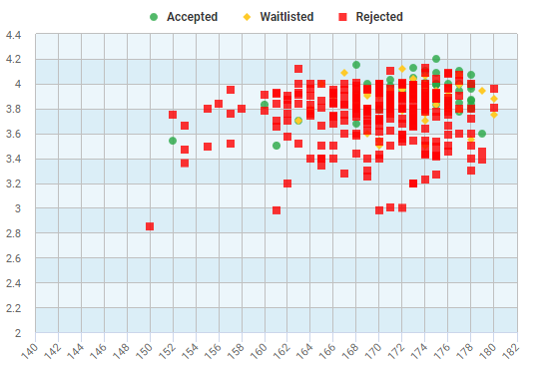](http://bc.lawschoolnumbers.com/stats/2122)](http://bc.lawschoolnumbers.com/stats/2122)

## BC LAW SCHOOL COMPARISON TOOL

#### BC Law School



**See how BC Law School compares to other schools.**

Akron Law School Albany Law School American Law School Appalachian Law School Arizona Law School Arkansas Law School ASU Law School Ave Maria Law School Barry Law School Baylor Law School Belmont Law School Berkeley Law School Brooklyn Law School BU Law School BYU Law School Cal Western Law School Campbell Law School Capital Law School Case Western Law School Catholic Law School Chapman Law School Charleston Law School Charlotte School of Law Chicago-Kent College of Law Cincinnati Law School Cleveland State Law School Colorado Boulder Law School Columbia Law School Cornell Law School Creighton Law School CUNY Law School Dalhousie Law School Dartmouth Dayton Law School Denver Law School DePaul Law School Drake Law School Drexel Law School Duke Law School Duquesne Law School Elon Law School Emory Law School FIU Law School Florida A&amp;M Law School Florida Coastal Law School Fordham Law School FSU Law School George Mason Law School Georgetown Law Golden Gate Law School Gonzaga Law School GSU Law School GW Law School Hamline Law School Harvard Law Hawaii Law School Hofstra Law School Howard Law School Inter American Law School IU Bloomington Law School IU Robert McKinney Law School John Marshall Law School John Marshall Law School Jones Law School La Verne Law School Lewis and Clark Law School Liberty Law School Loyola Chicago Law School Loyola Law School Loyola New Orleans Law School LSU Law School Maine Law School Marquette Law School McGill University Law School Memphis Law School Mercer Law School Miami Law School Mississippi Law School Missouri Law School Montana Law School MSU Law School Nashville School of Law NESL New Hampshire New York Law School NKU Law School North Carolina Central Law School Northeastern Law School Northern Illinois Law School Northwestern Law School Notre Dame Law School Nova Law School NYU Law School OCU Law School Oklahoma Law School Old Miss Law School ONU Law School Oregon Law School OSU Law School Pace Law School Pacific Law Penn Law School Penn State Law School Pepperdine Law School Phoenix School of Law Pitt Law School Pontifical Catholic Law School Puerto Rico Law School Queen's University Law School Quinnipiac Law School Regent Law School Richmond Law School Roger Williams Law School Rutgers Law School Rutgers Law School Camden Rutgers Law School Newark Samford Law School Santa Clara Law School SC Law School Seattle Law School Seton Hall Law School SIU Law School SMU Law School South Dakota Law School South Texas Law School Southern Law School Southwestern Law School St. John's Law School St. Louis Law School St. Mary's Law School St. Thomas Law School Stanford Law School Stetson Law School Suffolk Law School SUNY Buffalo Law School Syracuse Law School Temple Law School Texas A&M Texas Law School Texas Tech Law School Thomas M. Cooley Law School TJSL Toledo Law School Touro Law School TSU Law School Tulane Law School Tulsa Law School U Michigan Law School U of L Law School UALR Law School UB Law School UC Davis Law School UC Hastings Law School UCI Law School UCLA Law School UConn Law School UDC Law School UDM Law School UF Law School UGA Law School UIUC College of Law UK Law School UM Law School UMKC Law School UMN Law School UMN Law School UNC Law School UND Law School University of Alabama Law School University of Alberta Law School University of British Columbia Law School University of Calgary Law School University of Chicago Law School University of Houston Law School University of Idaho Law School University of Iowa Law School University of Kansas Law School University of Manitoba Law School University of New Brunswick Law School University of Ottawa Law School University of Saskatchewan Law School University of Toronto Law School University of Victoria Law School University of Western Ontario Law School University of Windsor Law School UNL Law School UNLV Law School USC Law School USD Law School USF Law School UST Law School UTK Law School UU Law School UVA Law School Valpo Law School Vanderbilt Law School Vermont Law School Villanova Law School Wake Forest Law School Washburn Law School Washington Law School Wayne State Law School Western State Law School Whittier Law School Widener Law School Willamette Law School William and Mary Law School William Mitchell Law School Wisconsin Law School WLU Law School WNEC Law School WUSTL Law School WVU Law School Wyoming Law School Yale Law Yeshiva Law School York University Law School



**Select another school to compare to BC Law School.**

### Suggested Schools

* [UGA Law School](http://georgia.lawschoolnumbers.com/)
* [GW Law School](http://gw.lawschoolnumbers.com/)
* [ASU Law School](http://asu.lawschoolnumbers.com/)
* [WLU Law School](http://wl.lawschoolnumbers.com/)
* [Fordham Law School](http://fordham.lawschoolnumbers.com/)
* [UC Davis Law School](http://davis.lawschoolnumbers.com/)

## BC LAW SCHOOL COMMUNITY

BC Law School is considered to have a **Favorable** student to faculty ratio. The average class size for 1L sections is approximately **Above Average** compared to other law schools. Student diversity at Bc is **Below Average**.

### Student Body

Student GenderMenWomen46.1%53.9%

| **Sex** | **Count** |
| --- | --- |
| Men | 374 |
| Women | 320 |

Student EthnicityHispanicsAmerican IndianAsianAfrican AmericanOthersCaucasian8.8%10.6%4.5%2.9%73.1%

| **Race** | **Count** |
| --- | --- |
| Hispanics | 55 |
| American Indian | 1 |
| Asian | 66 |
| African American | 28 |
| Pacific Islander | 0 |
| Others | 18 |
| Caucasian | 457 |

### Faculty Statistics

* **Full Time:49**
* **Part Time:42**

### Faculty

* **# Female Faculty:43**
* **# Minority Faculty:14**

### Ratio

#### 14.2 Students

#### 1 Faculty

### Housing Options

* **On Campus Housing:Yes**
* **Graduate Housing:Yes**
* **Law Specific Housing:Yes**

## BC LAW SCHOOL CURRICULUM

The size of 1L sections affects the quality and consistency of teaching in law schools. Generally with smaller 1L section sizes, students receive more individualized attention.**BC Law School** 1L section size is **8% larger than** law schools in **Massachusetts** and**20% larger than** all **PRIVATE** law schools.

### 1L Section Size Comparison

**BC Law School: 183**

**Massachusetts Average: 168**

**PRIVATE School Average: 146**

#### Positions Available in Advanced Courses

* **Simulation Courses:560**
* **Faculty Supervised Clinics:144**

#### Students Involved in Advanced Activities

* **Field Placements:182**
* **Law Journals:171**
* **Moot Court/Mock Trials:0**

### Attrition Rates

* **First Year:5.7%**
* **Second Year:1.3%**
* **Third Year:1.3%**
* **Fourth Year:0.0%**

## BC LAW SCHOOL EMPLOYMENT

Deciding to attend law school requires a large financial investment with the goal of securing employment upon graduation. The **BC Law School** class of **2020** had an employment rate of **92%** with **1%** pursuing an additional degree.

### Employment Comparison

School EmploymentEmployedAdditional DegreesUnemployed0102030405060708090100Highcharts.com

In **2020**, 71.0%% of students reported their employment status 9-months after graduation.

### Type Of Employment

* **Law Firms:54.0%**
* **Business:13.0%**
* **Government:13.0%**
* **Public Interest:8.0%**
* **Academia:1.0%**
* **Massachusetts:50%**
* **New York:13%**
* **Florida:5%**

### Bar Passage Rates

* **Reporting:71.0%**
* **First Time Takers:262**
* **Average School:90.9%**
* **Average State:83.2%**
* **Pass Difference:7.7%**

### Top Bar Jurisdiction

* **Massachusetts:83.2%**
* **Passed:169 of 186 (90.9%)**
* **State Average:83.2%**
* **Difference:7.7%**

Change School

Change SchoolAlbany Law School of Union University American University Appalachian School of Law Arizona State University Ave Maria University School of Law Barry University School of Law Baylor University Belmont University College of Law Boston College Boston University Brigham Young University Brooklyn Law School California Western School of Law Campbell University Capital University Cardozo-Yeshiva University Case Western Reserve University Catholic University of America Chapman University Charleston School of Law Charlotte School of Law Chicago-Kent College of Law (IIT) Cleveland State University College of William and Mary Columbia University Cornell University Creighton University CUNY Queens College Dalhousie University DePaul University Drake University Drexel University Duke University Duquesne University Elon Law School Emory University Florida A&amp;M University Florida Coastal School of Law Florida International University Florida State University Fordham University George Mason University George Washington University Georgetown University Georgia State University Golden Gate University Gonzaga University Hamline University Harvard University Hofstra University Howard University Indiana University Bloomington Indiana University Robert H. McKinney School of Law Inter American University School of Law John Marshall Law School - Atlanta John Marshall Law School - Chicago Jones School of Law Lewis and Clark College Liberty University Louisiana State - Baton Rouge Loyola Law School Loyola University Chicago Loyola University New Orleans Marquette University McGill University Mercer University Michigan State College of Law Mississippi College Nashville School of Law New England School of Law New York Law School New York University North Carolina Central University Northeastern University Northern Illinois University Northern Kentucky University Northwestern University Nova Southeastern University Ohio Northern University Ohio State University Oklahoma City University Pace University Penn State University (Dickinson) Pepperdine University Phoenix School of Law Pontifical Catholic University Queen's University Quinnipiac University Regent University Roger Williams University Rutgers Law School Rutgers State University Camden Rutgers State University Newark Samford University Santa Clara University Seattle University Seton Hall University South Texas College of Law Southern Illinois University Carbondale Southern Methodist University Southern University Southwestern University School of Law St. John's University St. Louis University St. Mary's University St. Thomas University - Florida Stanford University Stetson University Suffolk University Syracuse University Temple University Texas A&M University School of Law Texas Southern University Texas Tech University The University of Massachusetts School of Law-Dartmouth Thomas Jefferson School of Law Thomas M Cooley Law School Touro College Tulane University University at Buffalo University of Akron University of Alabama University of Alberta University of Arizona University of Arkansas Fayetteville University of Arkansas Little Rock University of Baltimore University of British Columbia University of Calgary University of California Berkeley University of California Davis University of California Hastings University of California Irvine University of California Los Angeles University of Chicago University of Cincinnati University of Colorado Boulder University of Connecticut University of Dayton University of Denver University of Detroit Mercy University of Florida University of Georgia University of Hawaii University of Houston University of Idaho University of Illinois Urbana-Champaign University of Iowa University of Kansas University of Kentucky University of La Verne College of Law University of Louisville University of Maine University of Manitoba University of Maryland University of Memphis University of Miami University of Michigan Ann Arbor University of Minnesota Twin Cities University of Mississippi University of Missouri Columbia University of Missouri Kansas City University of Montana University of Nebraska Lincoln University of Nevada Las Vegas University of New Brunswick University of New Hampshire School of Law University of New Mexico University of North Carolina Chapel Hill University of North Dakota University of Notre Dame University of Oklahoma University of Oregon University of Ottawa University of Pennsylvania University of Pittsburgh University of Puerto Rico University of Richmond University of San Diego University of San Francisco University of Saskatchewan University of South Carolina University of South Dakota University of Southern California University of St. Thomas - Minneapolis University of Tennessee Knoxville University of Texas Austin University of The District of Columbia University of the Pacific University of Toledo University of Toronto University of Tulsa University of Utah University of Victoria University of Virginia University of Washington University of Western Ontario University of Windsor University of Wisconsin Madison University of Wyoming Valparaiso University Vanderbilt University Vermont Law School Villanova University Wake Forest University Washburn University Washington and Lee University Washington University in St Louis Wayne State University West Virginia University Western New England College School of Law Western State University Whittier Law School Widener University Willamette University William Mitchell College of Law Yale University York University (Osgoode Hall)

**LEXICON**

Bar admissions : admission au barreau

Bar Association : Le barreau (American Bar Association)

Business Law: droit des affaires

Civil procedure : procédure civile

Contract : Le contrat

Constitutional law : droit constitutionnel

Criminal law : droit pénal

Family Law : droit de la famille

International Law: droit international

Law of Torts : la responsabilité civile délictuelle

Law of property : droit des biens

Legal aid: l’assistance juridique

Legal education : les études de droit

Legal practice : La carrière juridique

Litigation : contentieux

Moot Court : Exercice de plaidoirie- simulation de procès (aussi « Mock trial »)

Oath declaring : prestation de serment

Professional ethics : déontologie