* Texte 13: PM backs JK Rowling's views on new hate crime law

The prime minister has said people should not be criminalised "for stating simple facts on biology" in response to JK Rowling's criticism of Scotland's new hate crime law. The author took to social media to hit out at the Hate Crime and Public Order (Scotland) Act which came into effect on Monday.

5 The law creates a new crime of "stirring up hatred" relating to protected characteristics.

Rishi Sunak said the UK had a proud tradition of free speech.

In a series of social media posts, Ms. Rowling described several transgender women as men, including convicted prisoners, trans activists and other public figures. The Harry Potter author, who lives in Edinburgh but who is understood to currently be abroad, then invited police to arrest her if

10 they believed she had committed an offence.

The prime minister would not be drawn on whether he supported her approach, saying that it was "not right for me to comment on police matters, individual matters". But he added: "We should not be criminalising people saying common sense things about biological sex, clearly that isn’t right. "We have a proud tradition of free speech."

15 Under the new law, "stirring up hatred" relating to age, disability, religion, sexual orientation, transgender identity or being intersex is now classed as a criminal offence.

First Minister Humza Yousaf said the law was designed to deal with what he called a "rising tide of hatred" in society.

Writing on X, Ms Rowling said "freedom of speech and belief" was at an end if accurate description

20 of biological sex was outlawed. Ms. Rowling, who has long been a critic of some trans activism, raised concerns that the law did not protect women as a group from hatred.

The Scottish government is expected to include this later in a separate misogyny law.

The maximum penalty under the new act in Scotland is a jail sentence of seven years.

A person commits an offence if they communicate material, or behave in a manner, "that a

25 reasonable person would consider to be threatening or abusive," with the intention of stirring up hatred based on protected characteristics.

Stirring up hatred based on race, sexual orientation and religion was already illegal in Great Britain under the Public Order Act 1986, but that will also now fall under the new act in Scotland. The bar for this offence is lower than for the other protected characteristics, as it also includes "insulting"

30 behaviours.

SNP ministers, who brought in the legislation have been asked whether Ms. Rowling's comments, and acts such as mis-gendering would be classed as criminal under the new laws.

Speaking to BBC Radio's Good Morning Scotland programme, Health Secretary Neil Gray said he would not comment on individual circumstances but said the "bar is much higher" than Ms. Rowling

35 was suggesting.

He said offences had to include the use of "threatening or abusive language or behaviour" and that the "protection of freedom of expression" was included within the legislation.

Mr. Gray said the new law was an extension of existing laws that had protected people from hate crimes on the basis of their race under the Public Order Act 1986. He said he hoped it would help

40 tackle the "hatred that has been permeating across these isles for far too long" and that there would be similar protection to that offered in relation to race for the past 40 years.

**Le plan historique**

1. Before the Reforms
2. The declaration of JK Rawling
3. The reactions
4. The Reforms
5. A Scottish New Act
6. The New elements of the Law

**Le plan logique**

Inventaire indicatif des **plans logiques purs** :

* conditions/effets

1. The conditions of the Woke Theory
2. The declaration of JK Rawling
3. The decision to fight these positions
4. The legislation
5. The new legislation In Scotland
6. The existing laws in England

* domaine/portée ;
* notion/Régime
* critères/conséquences ;
* nature/objet.

Inventaire indicatif des **plans logique d'opposition**. –

* principe/exception ;
* ressemblances/différences ;
* avantages/inconvénients ;
* intérêt/danger ;
* volonté des parties/ordre public ;
* droit/devoir/Obligation.

Bien sûr, les titres de ces parties doivent être complétés, ne serait-ce que pour respecter le principe du parallélisme des titres.

**Plans assimilés aux plans logiques**.

C'est dans cette rubrique qu'il faut rattacher les plans :

* présentant dans une première partie les solutions possibles et dans la seconde partie la solution retenue ;
* décrivant dans une première partie les multiples aspects d'un phénomène et dans une seconde partie les effets du choix de l'un de ces aspects.

**Le plan distributif**

– **Plan distributif matériel.** –

1. The Criminal declarations
2. The words used
3. The repent of the writer
4. The legislative reactions
5. Scotland
6. England

– **Plan distributif personnel**. –

* Texte 14: Starmer attacks Badenoch over call for new inquiry into sexual abuse gangs

### By Peter Walker Senior political correspondent, *The Guardian*, Wed 8 Jan 2025

Keir Starmer has accused Kemi Badenoch of “bandwagon jumping” in calling for a new inquiry into sexual abuse gangs, as he condemned the Conservative leader for her plan to try to vote down a bill on children’s wellbeing.

This is a figurative expression, which really means that you waited until an idea, activity or viewpoint became popular before you showed an interest in it. So, you are not really jumping onto anything, let alone a bandwagon. Therefore, it doesn't matter whether we use 'on' or 'onto'. FR/ « prendre le train en marche »

In sometimes bitter exchanges at prime minister’s questions, as the topic of grooming gangs

5 continued to dominate the political agenda, Starmer accused Badenoch of only taking an interest in the subject after Elon Musk repeatedly tweeted about it.

“She met her recently acquired view that it’s a scandal, having spent a lot of time on social media over Christmas,” the prime minister told the Conservative leader. “Not once in eight years did, she stand here and say what she just said.”

10 Starmer accused Badenoch, who had said resisting a new inquiry would spark speculation about a “cover-up” in government, of being more interested in “tweeting and talking” than taking action on behalf of victims. Noting that Badenoch had been children’s minister among other roles in the last government, Starmer said he was not aware of the Tory leader having previously raised in the Commons the subject of sexual abuse gangs.

15 “It’s only in recent days she’s jumped on the bandwagon,” he said. “If I’m wrong about that, and she has raised it, then I invite her to say that now, and I will happily withdraw the remark.”

Badenoch responded by saying she had “raised it in speeches”, and that as she was not a home Office minister, she would not have addressed it in the Commons.

Badenoch’s call for a new inquiry at PMQs comes before a vote in the Commons in which the

20 Conservatives will try to force an inquiry using an amendment to the children’s wellbeing and schools bill, which will be given its second reading on Wednesday.

Badenoch rejected Starmer’s argument that another national inquiry, after the report by Prof Alexis Jay, published in 2022, would merely delay the implementation of Jay’s recommendations.

“It is very possible to have actions, take on more, and still have a national inquiry,” she said. “So

25 why won’t he listen to victims and launch a national inquiry which would have the power to summon witnesses and make them give evidence under oath?”

Starmer replied by saying that he had met some survivors of grooming gangs earlier on Wednesday, and that they had told him they would rather have swift action rather than another inquiry. While saying he accepted that other survivors of the abuse took different views, Starmer angrily

30 condemned the planned amendment, which would stop the progress of the entire children’s wellbeing and schools’ bill.

While some of the bill is concerned with areas such as academy chains and school uniforms, it also seeks to tighten up some areas of child welfare, such as no longer automatically allowing parents to home-school a child if the child is subject to a child protection plan.

35 Starmer said this provision could help prevent cases like that of 10-year-old Sara Sharif, who had been taken out of formal schooling before she was murdered by her father and stepmother.

Starmer said he could not understand why Tory MPs would try to vote down a bill that would “protect children who are vulnerable”, adding: “I implore them, vote for the bill.”

Badenoch hit back, saying Starmer was ordering Labour MPs in towns and cities affected by 40 grooming gangs to vote against an inquiry into “one of the worst scandals in British history”.

**Le plan historique**

1. The “grooming gangs”
2. The number of the victims
3. The grooming technique
4. The defect of English Justice
5. Role of Keith Starmer
6. The Suits

**Le plan logique**

Inventaire indicatif des **plans logiques purs** :

* conditions/effets

1. The Reasons of the political scandal
2. The number of the victims
3. The grooming technique
4. The effects
5. Most of important cases have been tried
6. Necessity to search for other case

* domaine/portée ;
* notion/Régime
* critères/conséquences ;
* nature/objet.

Inventaire indicatif des **plans logique d'opposition**. –

* principe/exception ;
* ressemblances/différences ;
* avantages/inconvénients ;
* intérêt/danger ;
* volonté des parties/ordre public ;
* droit/devoir/Obligation.

Bien sûr, les titres de ces parties doivent être complétés, ne serait-ce que pour respecter le principe du parallélisme des titres.

**Plans assimilés aux plans logiques**.

C'est dans cette rubrique qu'il faut rattacher les plans :

* présentant dans une première partie les solutions possibles et dans la seconde partie la solution retenue ;
* décrivant dans une première partie les multiples aspects d'un phénomène et dans une seconde partie les effets du choix de l'un de ces aspects.

**Le plan distributif**

– **Plan distributif matériel.** –

I The Criminal cases

1. THE CRIMES
2. THE IMPORTANT NUMBERS between 2.000 AND 200.000

II. THE NECESSITY OF JUSTICE

1. The increase of the means
2. The necessity to regulate

– **Plan distributif personnel**. –

1. Reducing the delays and the victims
2. Necessity for the victims
3. The reasons of the delays

II. Reducing the delays and the judges

1. The necessity to have a schedule
2. The means necessary to reach the aim

**history**

*From the late 1980s until 2013, group-based child sexual exploitation affected an estimated 1,400 girls, commonly from care home backgrounds, in the town of Rotherham, South Yorkshire, England. Between 1997 and 2013, girls were abused by "grooming gangs" of predominantly British Pakistani men. Researcher Angie Heal, who was hired by local officials and warned them about child exploitation occurring between 2002 and 2007, has since described it as the "biggest child protection scandal in UK history".*

*Evidence of the abuse was first noted in the early 1990s, when care home managers investigated reports that children in their care were being picked up by taxi drivers. From at least 2001, multiple reports passed names of alleged perpetrators, several from one family to the police and Rotherham Council. The first group conviction took place in 2010, when five British Pakistani men were convicted of sexual offences against girls aged 12–16. From January 2011, The Times covered the issue, discovering that the abuse had been known by local authorities for over ten years.*

*Following these reports, alongside the 2012 trial of the Rochdale child sex abuse ring, the House of Commons Home Affairs Committee conducted hearings and published its recommendations in six reports. Alexis Jay led an independent inquiry, known as the Jay report, which found multiple failings of the police and local authorities. Girls would be regularly taken in taxis to be abused, and were gang raped, forced to watch rape, threatened, and trafficked to other towns. The pregnancies, miscarriages, and terminations which resulted caused further trauma to the victims. Most victims were White British girls, but British Asian girls were also targeted. British Asian girls may have feared social isolation and dishonour had they reported their experiences. Failure to address the abuse has been linked to factors such as fear of racism allegations due to the perpetrators' ethnicity; sexist attitudes towards the mostly working-class victims; lack of a child-centred focus; a desire to protect the town's reputation; and lack of training and resources.*

*Following the Jay report, Rotherham Council's chief executive, its director of children's services, as well as the Police and Crime Commissioner for South Yorkshire Police all resigned. The Independent Police Complaints Commission and the National Crime Agency both opened inquiries. The Rotherham Council was also investigated and found to be "not fit for purpose". 19 men and two women were convicted in 2016 and 2017 of sexual offences in the town dating back to the late 1980s.*

**KEMI BADENOCH: The only way to expose those who turned a blind eye to the grooming gangs is by holding a full public inquiry**

* **PODCAST:**[**Former detective Maggie Oliver shares the inside story on how she brought down the Rochdale grooming gangs**](https://dailymail.lnk.to/maggie-oliver-eikamDM!bl)

By KEMI BADENOCH LEADER OF THE OPPOSITION

**PUBLISHED:** 23:27 GMT, 4 January 2025 | **UPDATED:** 21:41 GMT, 7 January 2025

Britain has witnessed the mass grooming of thousands of the most vulnerable white working-class girls – children – by gangs of men, many of Pakistani heritage. This was rape on an industrial scale.

And shockingly, it was a scandal made possible by the collusion and cover-ups of officials, the police and politicians who were more concerned about community relations than about victims and their families.

The fact that perpetrators of this sexual violence appeared to have deliberately picked victims because they were white – and not from their own of the community or religious background – must not be ignored.

Previous inquiries have failed to examine this. It’s for society and the state to address the issue, no matter how uncomfortable it may be.

The testimonies of the victims are hard to read. Girls being forced into barbaric sexual acts. Raped by multiple men at the same time or one after the other. Punished by grotesque sexual violence when they resisted.

Children were identified as targets because of their backgrounds and experienced years of systematic abuse from adult men whose communities in some cases even helped protect them.

Thousands of girls’ lives have been damaged or destroyed. Worse still, this was perpetrated not in one rotten borough by a few rotten individuals, but across the nation.

It is just as disturbing to read accounts of collusion between officials and police – people entrusted with protecting the public – to keep the scandal under wraps, and in some cases even to allow the abuse to continue.

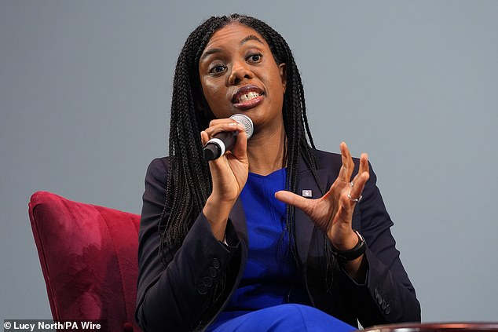

**+6**

View gallery

**Thousands of girls’ lives have been damaged or destroyed. Worse still, this was perpetrated not in one rotten borough by a few rotten individuals, writes Kemi Badenoch (pictured)**

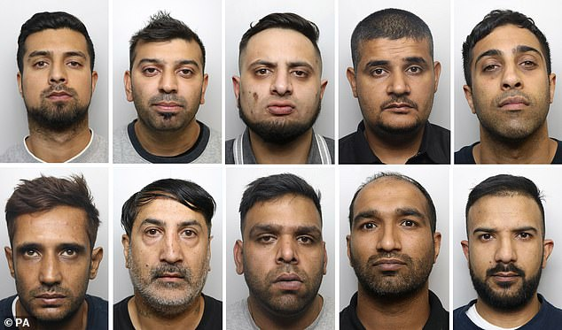

**+6**

View gallery

**Members of the Huddersfield Grooming gang who were jailed for 200 years in 2018 for serious sexual offences against teenage girls in three trials at Leeds Crown Court**