3. The Terms of the Contract

3.1. Contractual Terms
In addition to what the parties state expressly, both general trade custom and the parties' ways of dealing in prior commercial relationships may be important for the determination of the content that they intended for their contract.
Common law contains the pervasive mandate for the observance of good faith.

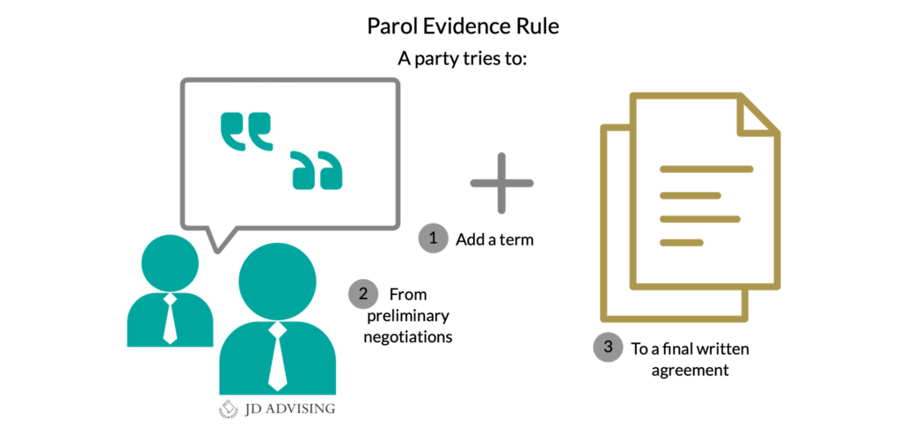

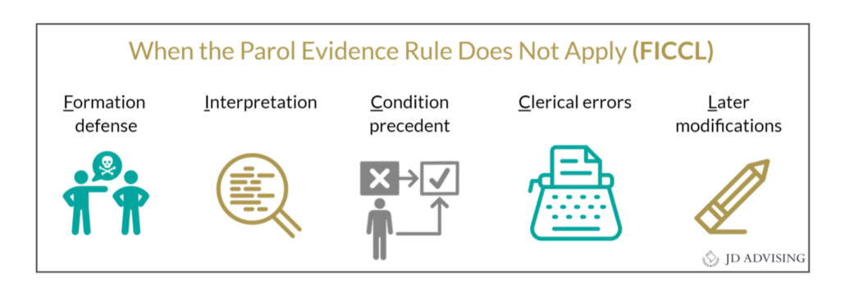
The terms of a contract may or may not be contained in a single document; they, in fact, must be pieced together from both written statements and oral testimony. In these circumstances, the "parol evidence rule" provides important limitations on what arguments a party may advance to prove the content of the contract. Originally, as the name indicates, the rule was one of evidence (procedure); today, it delineates the substantive content of a contract. It determines what oral agreements between the parties may be invoked in order to derogate from, or to supplement, the written memorandum; the decision on admissibility is one for the judge and not for the jury (a question of law)." If the contracting parties agree that they have concluded a final contract, which contains a "complete expression of their agreement, no earlier or contemporaneous oral agreements may be shown to change or supplement that contract. The contract is limited to the content of the written record."

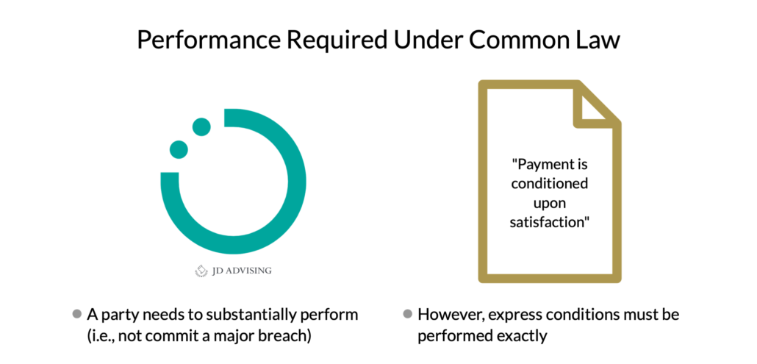

The rationale is that the written instrument incorporates (merges) the totality of the expression of the will of the parties: it is a (fully) "integrated" contract. Additional oral agreements between parties can become part of a contract, otherwise reduced to writing, in only two ways:
(1) a party may claim that the written instrument does not represent a final expression of the will of the parties,
(2) additional agreements may be binding on parties in circumstances in which it would be unusual that they would have been included in the original contract. The parol evidence rule, however, does not apply when a party claims and proves that the written contract is a result of mistake and must be disregarded or limited for that reason.

If there is a complete integration (usually a merger clause), nothing comes in.
If there is a partial integration, consistent additional terms are allowed in.

FOUR CORNERS




“The Eleventh Circuit Court of Appeals recently held that the plain text of an insurance policy trumps the parties’ subjective intent and expectations to the contrary, reversing the trial court’s entry of summary judgment. Shiloh Christian Center v. Aspen Specialty Ins. Co., No. 6:20-cv-01774-CEM-LHP, 2023 WL 2920573, at *1 (11th Cir. Apr. 13, 2023).
Hurricanes Matthew and Irma each made landfall upon Melbourne, Florida, peeling back Shiloh Christian Center’s (“the Church”) roof, allowing rain to damage the interior. In 2015, the year before Matthew hit, the Church’s policy with Aspen Specialty Insurance Company (“Aspen”) provided coverage for losses resulting from named windstorms (i.e., hurricanes). Halfway through 2015, the Church asked Aspen to stop covering named-windstorm-related losses and Aspen agreed. To reflect their agreement, Aspen issued an endorsement removing the named windstorm coverage from the policy, reduced the Church’s premium, and refunded its past payments for named-windstorm coverage.
In early 2016, the Church began negotiations to renew its policy and received a quote from Aspen reflecting the same coverage it had after the windstorm exclusion was added. In its application for the 2016 policy, the Church wrote “EX wind” in the section labeled “forms and conditions to apply.” Aspen then issued a binder, which described the agreed-to scope of coverage as “All Risks of Direct Physical Loss or Damage excluding Flood, Earthquake and Named Windstorm.”
Thereafter, Aspen issued the 2016 policy. The cover page described the 2016 policy as a “renewal of” its 2015 predecessor policy. However, the language of these policies differed in a material way: the 2016 policy did not exclude named windstorms, though it contained a detailed accounting of the other policy exclusions.
While the 2016 policy was in force, Hurricane Matthew struck the Church and tore off the roof allowing rainwater to enter the interior. Aspen denied the claim on several grounds, one of which being (you guessed it) the named windstorm exclusion.
Several months later, the Church sought to renew its policy, and again requested on the application of insurance that the policy exclude named windstorms. Aspen issued a binder that reflected the exclusion, but this exclusion did not make it into the 2017 iteration of the policy.
The following year, in true Lemony Snicket fashion, another named windstorm (Hurricane Irma) tore the roof off the Church’s building. Water poured in, exacerbating the prior damage. Aspen, as it had the previous year, denied the Church’s claim for Hurricane Irma damage mainly based upon the Named Windstorm exclusion.
The Church sued Aspen for breach of contract and sought a declaration that the Matthew and Irma policies covered damage from named windstorms. The parties teed up the question of whether the policies provided coverage for the trial court with their respective cross-motions for summary judgment.
The trial court granted summary judgment in favor of Aspen, finding that “no reasonable jury” could find that the parties intended the policies to include coverage for named windstorms based on the overwhelming evidence of the parties’ subjective intent. In reaching this conclusion, the trial court reasoned that Aspen’s evidence of the parties’ intent was overwhelming: “[t]he explicit bargaining to remove named windstorm coverage, the reduced premiums that resulted from that bargaining, and the explicit language in the subsequent policy quotes” all proved that there should not be coverage for named windstorms under either the 2016 or 2017 policy. The Church appealed to the Eleventh Circuit.
On appeal, the Eleventh Circuit held that the 2017 policy unambiguously covers losses from windstorm and, even though the Church admitted that the 2016 policy was ambiguous, it also covers losses from named windstorms based on the guiding principles of policy interpretation.
As the Eleventh Circuit put it, Florida law is “ruthlessly straightforward” when it comes to interpreting unambiguous insurance policies. Where the policy language is plain and unambiguous, the terms of that policy govern. A court must interpret the policy in accordance with the plain meaning to give effect to the policy as written. Importantly, that is true even where extrinsic evidence contradicts the policy’s terms. Consistent with this tenet, Florida law holds that the policy’s terms govern even in a conflict between that and the insurance application, or other evidence of the parties’ subjective intent (no matter how weighty that evidence may be).
Here, the Eleventh Circuit found the terms of the 2017 policy to be unambiguous. The policy contained a provision broadly granting coverage for risks of direct physical loss, and then enumerated exclusions, which unsurprisingly did not include named windstorms. Therefore, the Court held that the 2017 policy unambiguously covered named windstorms. In reaching this conclusion, the Court could not consider the policy application because there was no ambiguity in the policy. Again, where the policy language conflicts with the application or other evidence of the parties’ subjective intent, the policy governs. The final leg of the Court’s opinion on the 2017 policy rested on the fact that there was an integration clause in the policy, which stated that the parties intended the written agreement to be the entire agreement.
Turning to the 2016 policy, the Church conceded the policy was ambiguous on its face due to conflict between the policy’s broad coverage clause and the Policy’s deductible provision which states, “DEDUCTIBLE: $5,000 Per Occurrence, except; $25,000 Per Occurrence as respects Wind and/or Hail (excluding Named Windstorm).” Because of the deductible provision’s closing parenthetical, there are two reasonable interpretations of the 2016 policy. One could read the closing parenthetical to “exclud[e]” coverage for “Named Windstorm[s]”; or to create a “Named Windstorm” “exclusion” to the $25,000 “exception,” making only named windstorms subject to the $5,000 deductible.
Where, as in this case, an insurance policy is facially ambiguous, Florida law is clear that the ambiguity must be resolved in favor of coverage and against the insurer, without regard to extrinsic evidence of the parties’ supposed intentions or expectations. Therefore, the Court held that the 2016 policy, like the 2017 policy, provided coverage for losses from named windstorms since the ambiguous policy language must be read to provide coverage for named windstorms. »

3.3. Conditions
In American law, a condition is an event, the occurrence (or non-occurrence) of which is a precondition for a contractual obligation to arise or to terminate. A condition may be an express or an implied term of a contract.

American law distinguishes between conditions that extinguish and those that suspend an obligation. A “condition coupled with a covenant” describes a condition that the party or parties undertake, in good faith, to bring about. The party must demonstrate that she attempted to bring about the condition; if it did not, it has breached the contract.
Changed circumstances may make a condition ineffective or inapplicable for reasons of impracticability. In rare cases, a court may use its equity-based corrective function to adjust a condition.

The performance or offer of performance, by the other party of his/her contractual duties - unless a different order of performance has been stipulated expressly - also serves as a condition for the performance of one's own duty: even without express stipulation, the tender or rendition of the counter-performance is a "constructive condition" (of exchange). The other party's duty to perform (and the satisfaction of the condition resting on the plaintiff) arises with the plaintiff's rendition of "substantial performance" (see immediately following) or the offer of full performance.

4. The Satisfaction of a Party's Contractual Duties: Performance

4.1. Common Law
Full performance is an extraordinarily strict requirement and thus has been softened in practice by the introduction of the doctrine of “substantial performance”.

The doctrine permits a party to demand counter-performance (subject to a deduction for provable damages) even though his own performance fell short in some respects (that it was not "full," but was only "substantial performance” of the obligation undertaken).

UCC: the seller must provide perfect tender of the goods (or the buyer can reject the goods).

Exception: Installment contract. The buyer cannot reject unless there is a “substantial impairment,” and even then, the seller may cure.

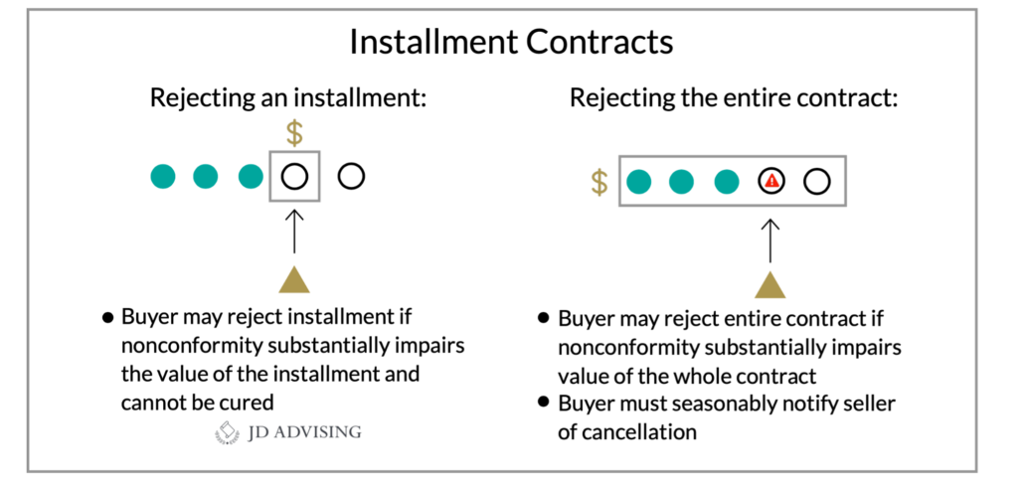

A buyer may accept or reject nonconforming goods. If he accepts goods, he may later revoke his acceptance, but revocation is a higher standard than rejection.
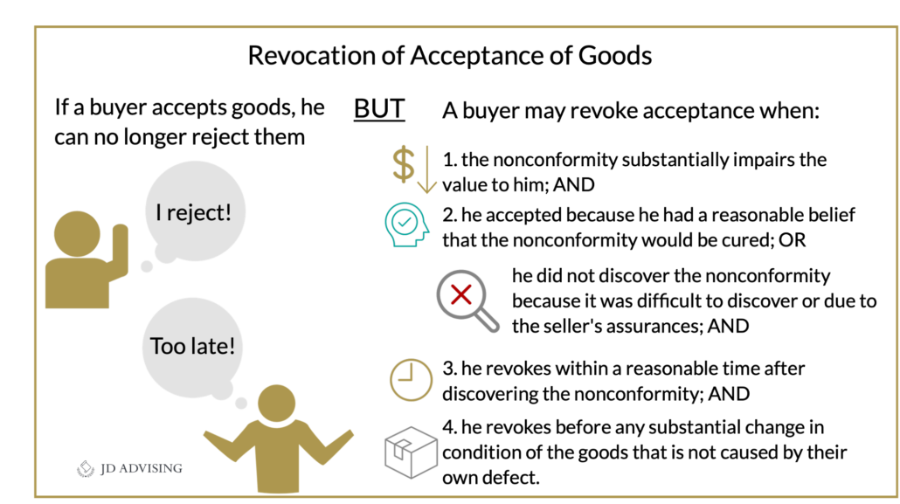

Delivery obligations
Carrier cases: Most are shipment contracts, and the seller only must get the goods to the “shipper” and the risk of loss (ROL) passes to the buyer. For destination contracts (limited to when the contract says “FOB Buyer’s Place of Business” or “Ex-Ship”), the seller must get it to the destination.

Excusing conditions
- If the other party breaches (i.e., an anticipatory repudiation vs. a prospective inability to perform)
- Waiver of condition

Discharging duties
- Performance
- Occurrence of a condition subsequent
- Agreement (novation, modification, accord and satisfaction, rescission, release)
- Changed circumstances so it becomes impossible, or the purpose is frustrated

